**Getting started with “dlgmsc_conf” project in IDE**

“dlgmsc_conf” part of the WebRTC Conference Demo application is an application which handles business logic and connectivity to Dialogic XMS Media Server via JSR 309 connector. It is an integral part of the demo and its counterpart ConvergedConferenceApp which is described in “Getting started with “ConvergedConferenceApp project in IDE”.

Steps to get the project up and running are:

1. Installation of JDK
2. Installation and general configuration of IDE – Eclipse
3. Unzipping of dlgmsc_conf project
4. Importing the dlgmsc_conf project inside Eclipse

Below are detailed steps on how to bring dlgmsc_conf project up on your local system for development/debugging purposes.

1. Install latest JDK (JDK 1.7 U 71 used here as an example)
2. Install Eclipse IDE for Java Developers (Eclipse Luna 4.4.1 used here as an example from eclipse.org)

* Start Eclipse and configure it for appropriate JDK as installed in step 1).

To do that, open up newly installed Eclipse and go to “Window”->”Prefrences”:

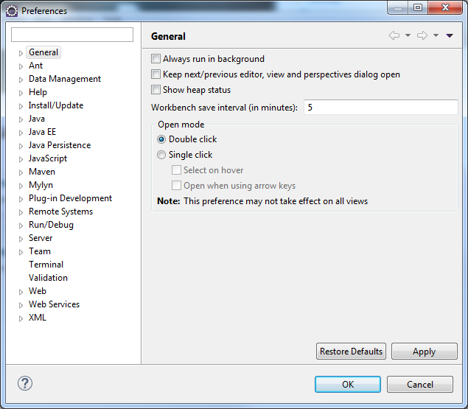

There select “Java”->”Installed JREs”:

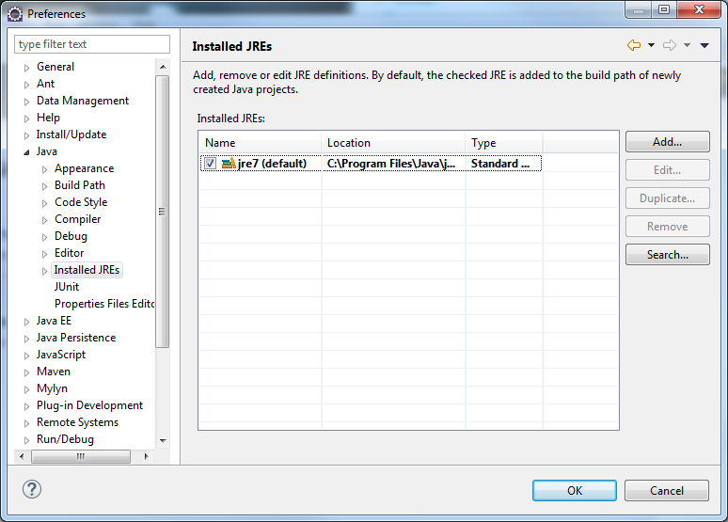

You might notice that Eclipse selected “jre 7” by default. This need to be changed and a reference to just installed JDK needs to be created. To do that click on “Add” button:

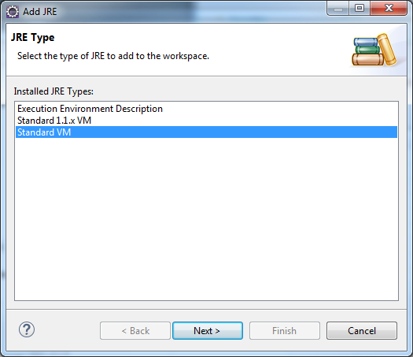

Select “Standard VM” and click “Next” button:

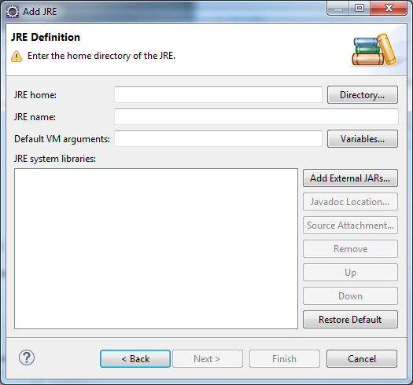

Here, click “Directory” button:

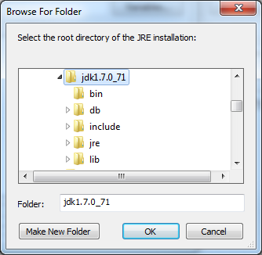

Navigate to the location of your JDK installation and click “OK” button:

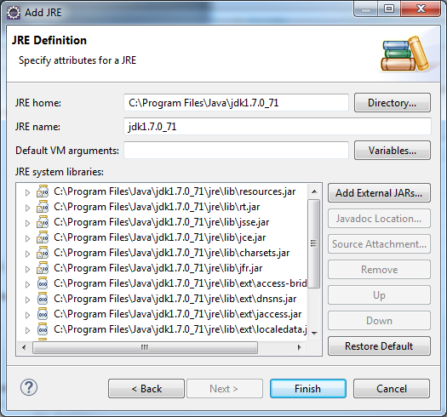

Now, click “Finish” button:

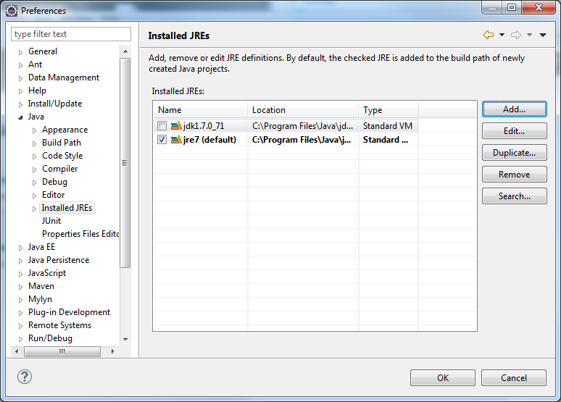

At this point jdk1.7.0_71 needs to be the only item selected. To do that, deselect jre7 and select jdk1.7.0_71 and then click “OK” button.

1. Now, unzip the project file dlgmsc_conf.tar and place its content in a known directory. Note, it needs to reside outside of the Eclipse workspace directory.
2. To open the project in Eclipse follow these simple steps:

* Open Eclipse:

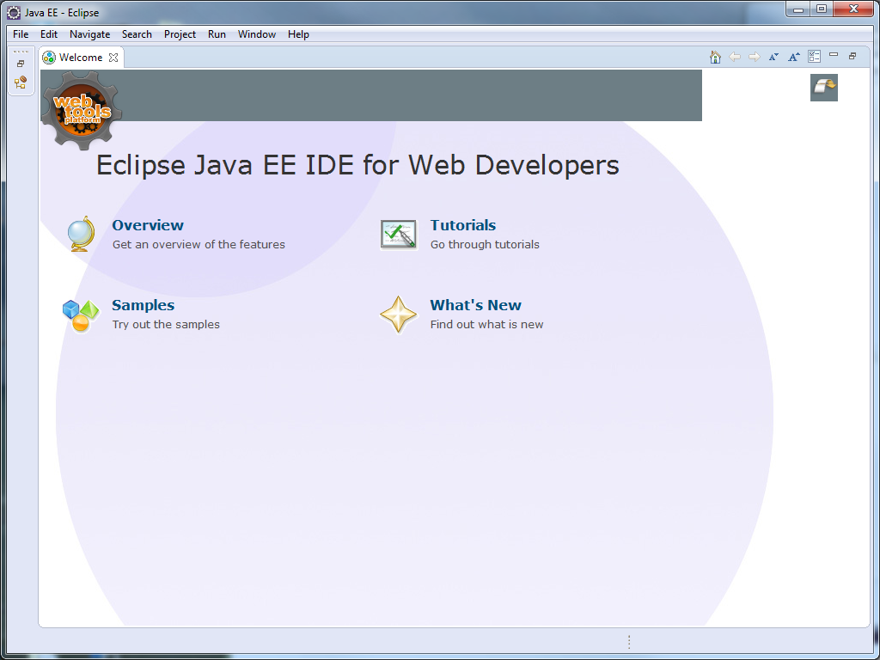

* Go to “File” menu

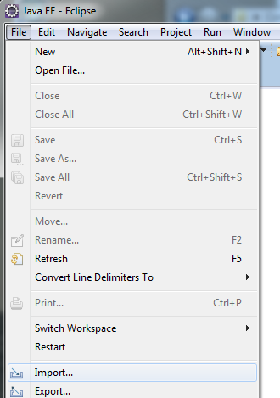

* Click “Import”:

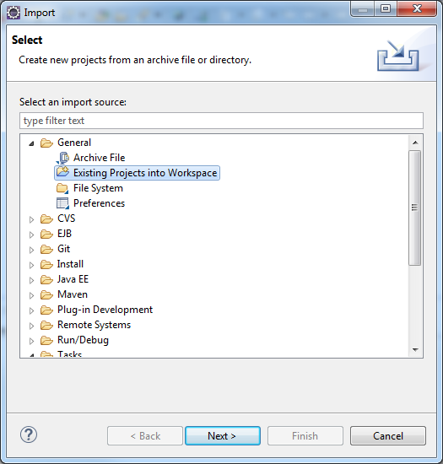

* Select “Existing Projects into Workspace” and click “Next”:

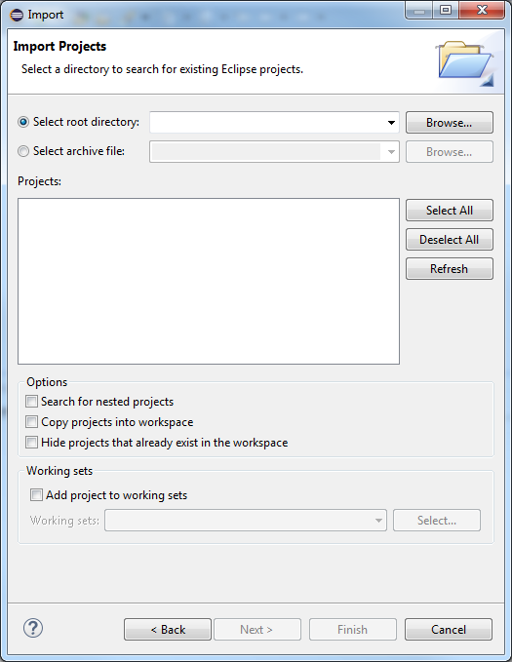

* click “Browse” button:

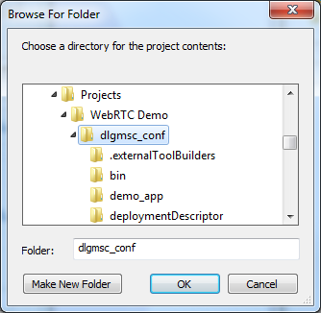

* Navigate to your project directory as created in step 3) and click “OK”:

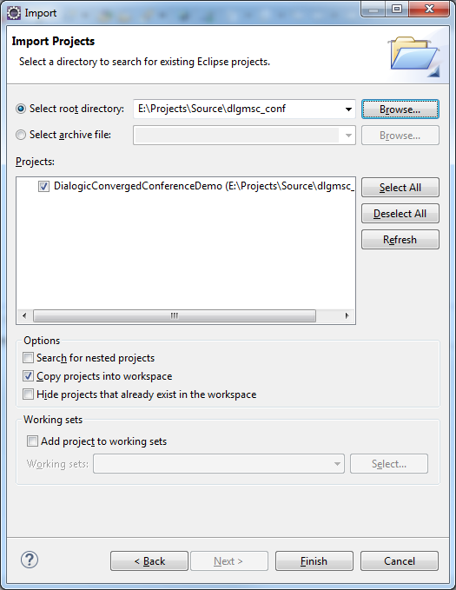

* Under “Options” select “Copy projects into workspace” and then click “Finish” button.
* At this point the project will appear in “Package Explorer” window:

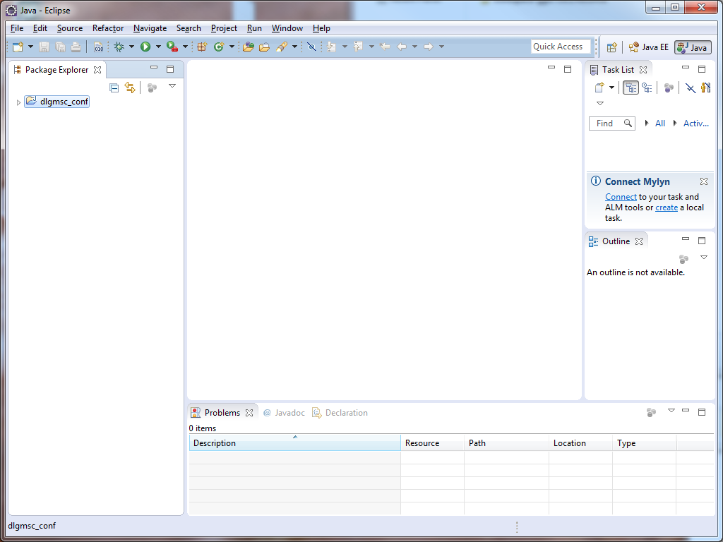

* Next, right mouse click on dlgmsc_conf and click Properties:

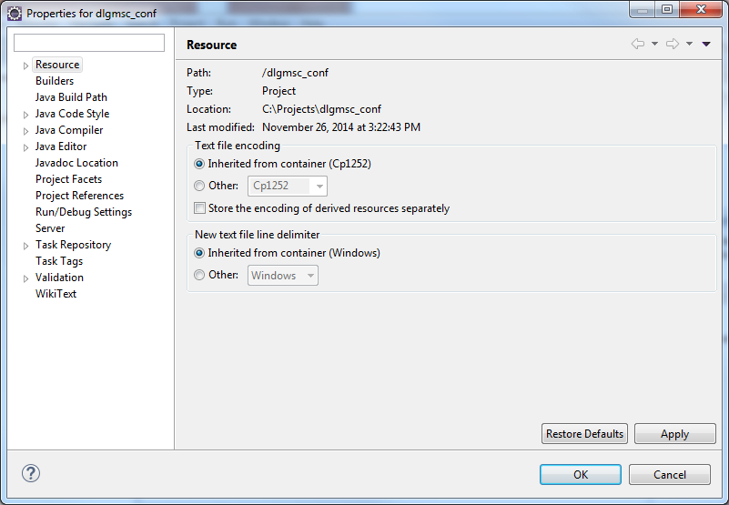

* Click on Builders:

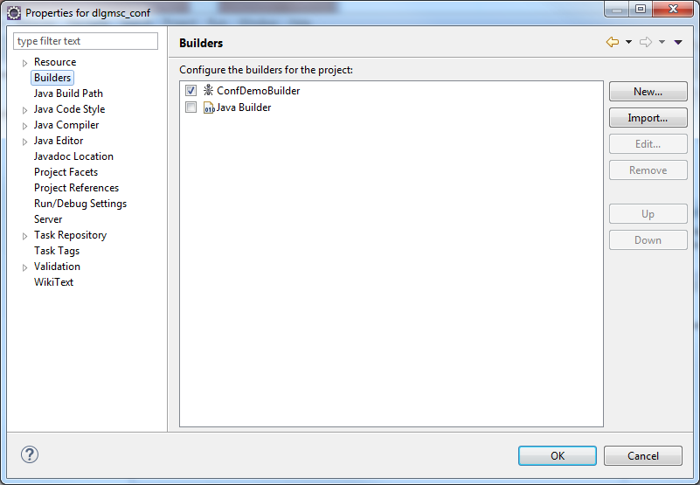

* Here double click on “ConfDemoBuilder” in order to set the right project properties to your local directory structure etc:

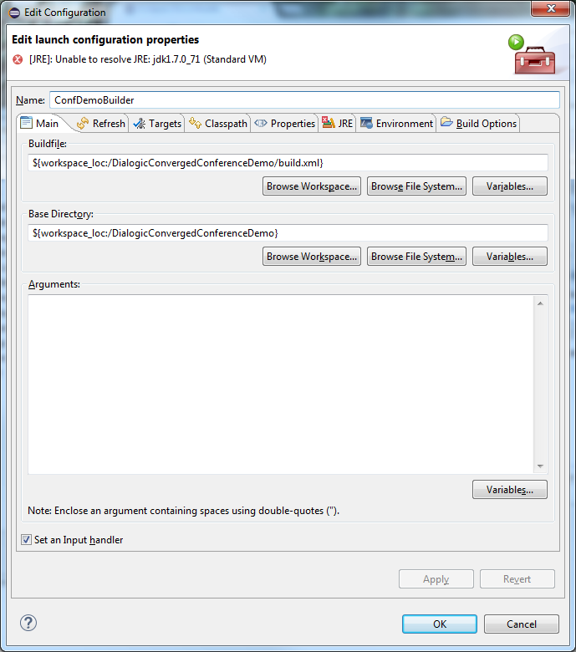

* As the above screen indicates we need to fix the JRE configuration. Simply click on “JRE” tab:

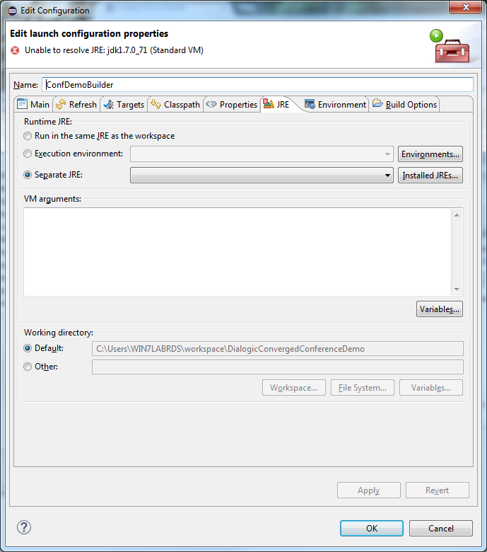

* Under “Runtime JRE” section make sure that “Separate JRE” is selected and that it is pointing to the appropriate JDK as installed in step 1:

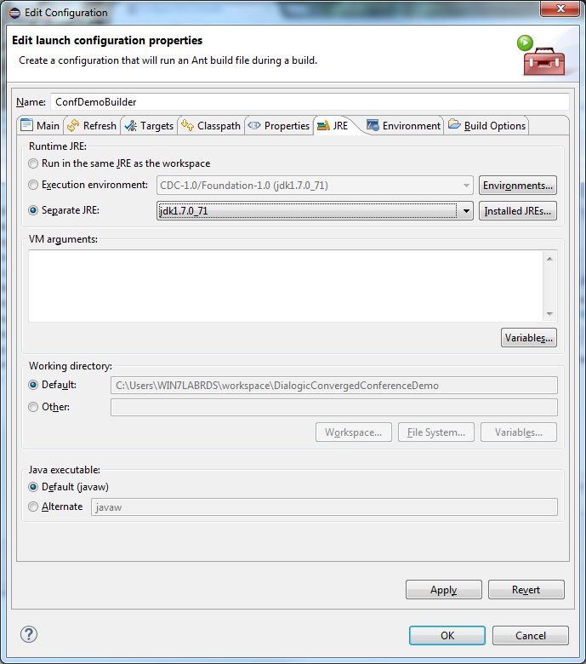

* Click “Apply” and then “OK” button:

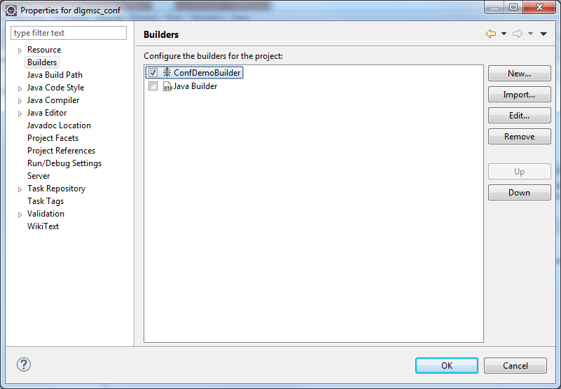

* Click “OK”. At this point you see Eclipse executing a build of the application. Successful build of the application will be indicated in a Console window of Eclipse project as following:

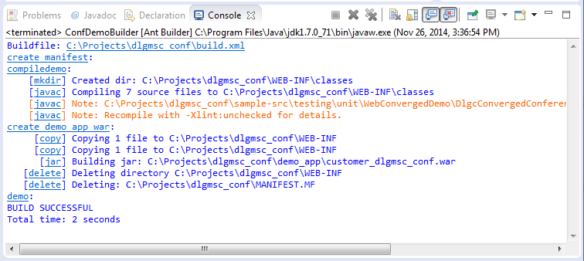

* At this point the new version of the business side of Converged Conference Application has been created and it can be used do deploy in TeleStax Application Server replacing the original as provided with a package. Note the location of the war file referenced in above screenshot.

**IMPORTANT NOTE**:

This application uses 3rd party jars which need to be downloaded from AS website by the user.

These jars include:

mscontrol.jar -> Available at jcp.org, after downloading place it under /lib/extjars while running the

server-api.jar ; sip-servlets-apec-X.X.XXX.jar -> These are platform specific jars, place them under /lib/tomcat/